**1. ls**

It lists the files and directories in the current directory.

*Syntax: ls [options] [directory]*

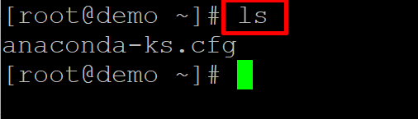

**2. cd**

Changes the current directory.

*Syntax: cd [directory]*

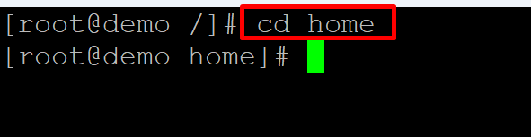

**3. pwd**

Shows the current working directory.

*Syntax: pwd*

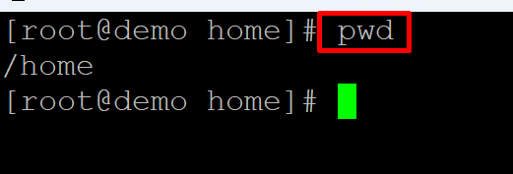

**4. Mkdir**

Creates a new directory.

*Syntax: mkdir [directory]*

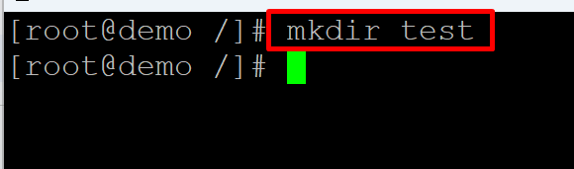

**5. rmdir**

Deletes an empty directory.

*Syntax: rmdir [directory]*

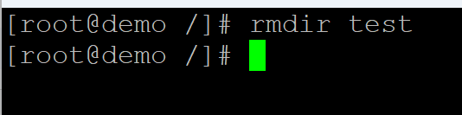

**6. rm**

Deletes a file or directory.

*Syntax: rm [file/directory]*

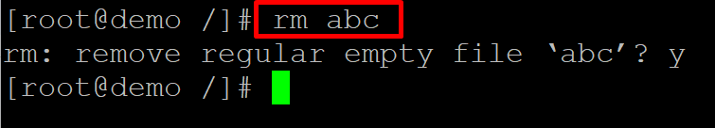

**7. cp**

Copies a file or directory.

*Syntax: cp [options] [source] [destination]*

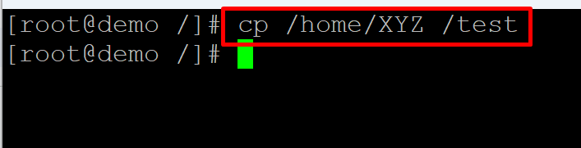

**8. mv**

Moves or renames a file or directory.

*Syntax: mv [options] [source] [destination]*

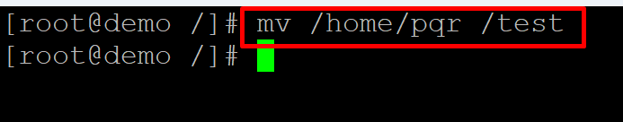

**9. touch**

Creates a new empty file.

*Syntax: touch [filename]*

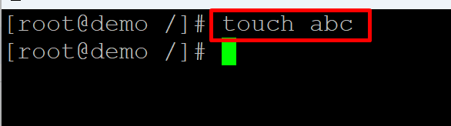

**10. cat**

Displays the contents of a file.

*Syntax: cat [filename]*

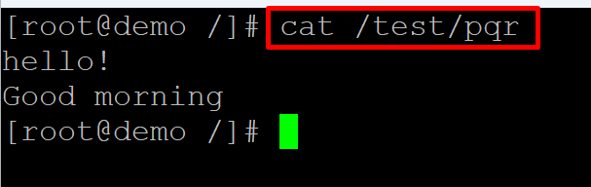

**11. less**

Displays the contents of a file one screen at a time.

*Syntax: less [filename]*

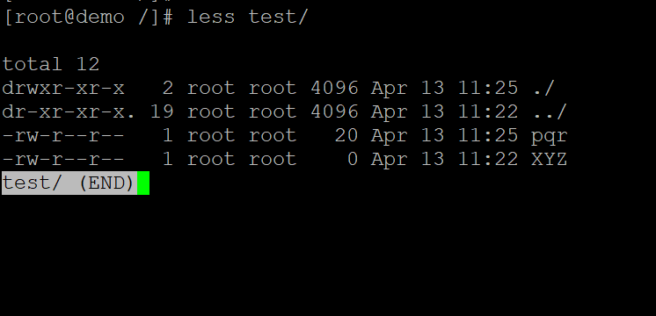

**12. head**

Displays the first few lines of a file.

*Syntax: head [filename]*

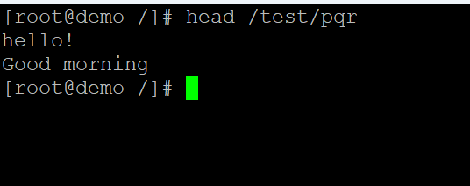

**13. tail**

Displays the last few lines of a file.

*Syntax: tail [filename]*

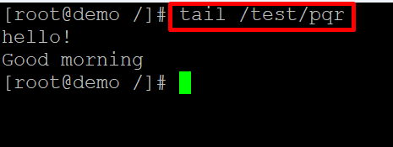

**14. grep**

Searches for a pattern in a file.

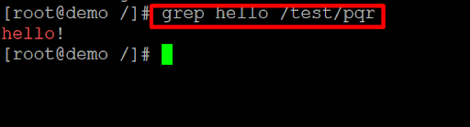

*Syntax: grep [options] [pattern] [filename]*

**15. find**

Searches for files in a directory hierarchy.

*Syntax: find [directory] [options] [expression]*

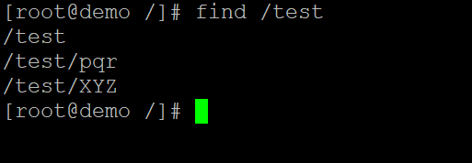

**16. tar**

Creates or extracts a compressed archive.

*Syntax: tar [options] [archive-filename] [files/directories]*



**17. gzip**

Compresses a file.

*Syntax: gzip [filename]*

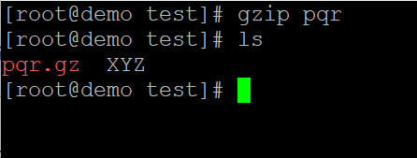

**18. gunzip**

Decompresses a compressed file.

*Syntax: gunzip [filename]*

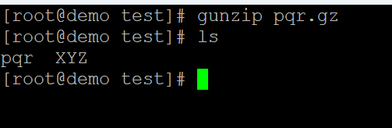

**19. bzip2**

Compresses a file.

*Syntax: bzip2 [filename]*

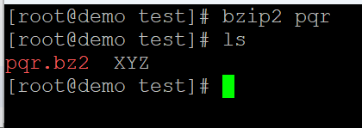

**20. bunzip2**

Decompresses a compressed file.

*Syntax: bunzip2 [filename]*

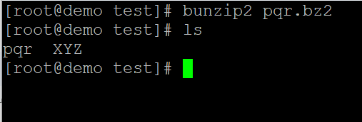

**du**

Shows the disk usage of files and directories.

*Syntax: du [options] [directory]*

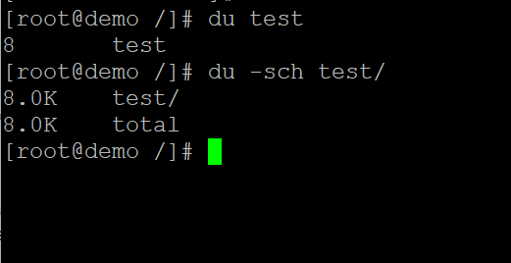

**df**

Shows the disk space usage of filesystems.

*Syntax: df [options]*

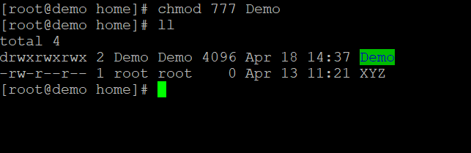

**top**

Displays the current system status.

*Syntax: top*

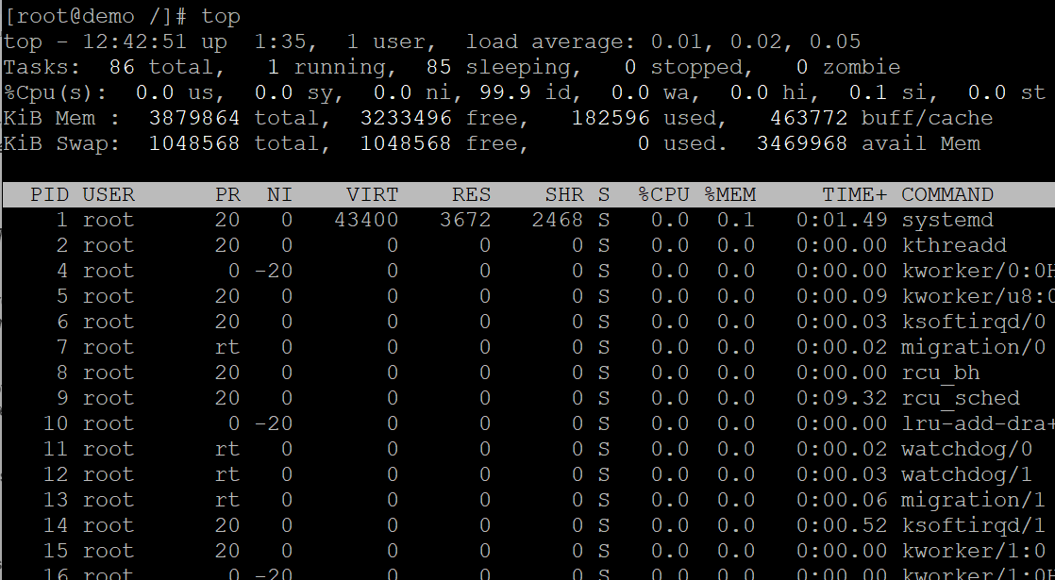

**ps**

Lists the currently running processes.

*Syntax: ps [options]*

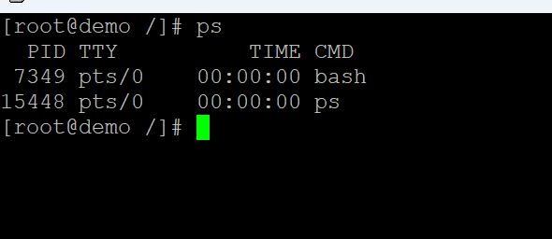

**kill**

Sends a signal to a process to terminate it.

*Syntax: kill [options] [PID]*

kill command

**ping**

Tests the network connectivity to a host.

*Syntax: ping [options] [hostname/IP address]*

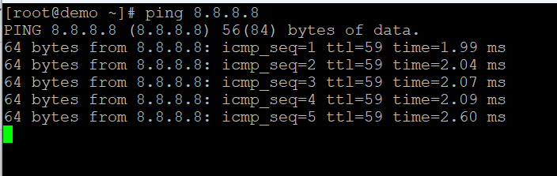

**ifconfig**

Configures network interfaces.

*Syntax: ifconfig [options] [interface]*

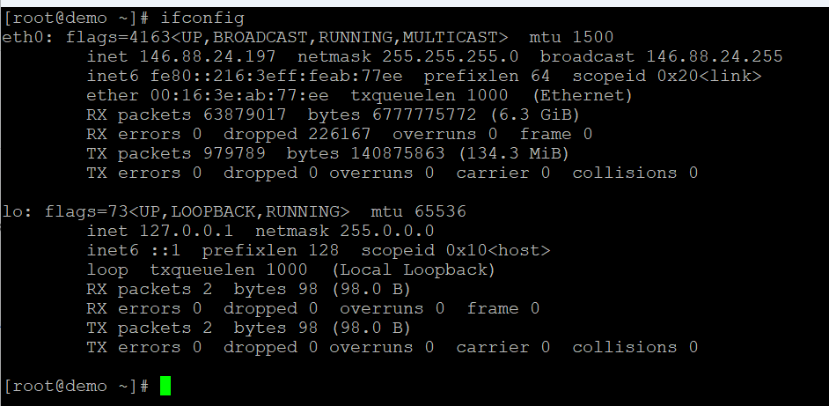

**netstat**

Shows network connections, routing tables, and network statistics.

*Syntax: netstat [options]*

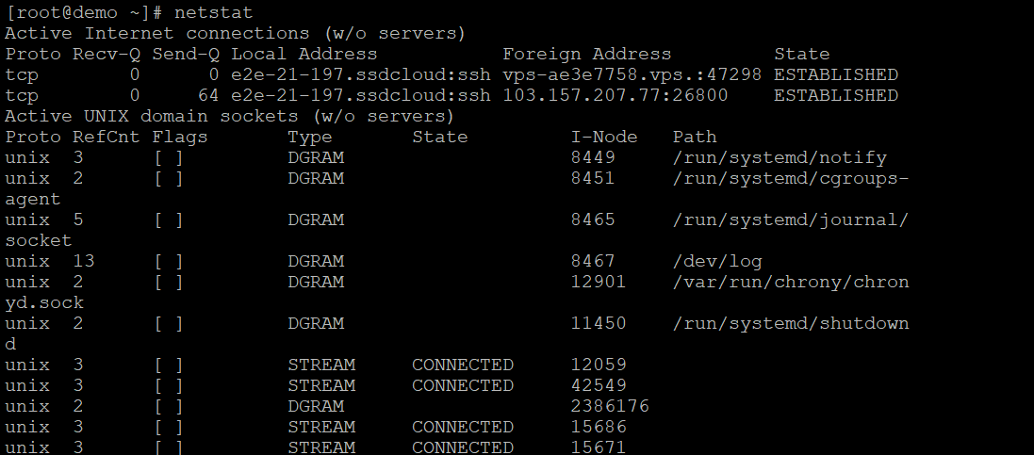

**ssh**

Connects to a remote host using SSH.

*Syntax: ssh [user@]hostname [command]*

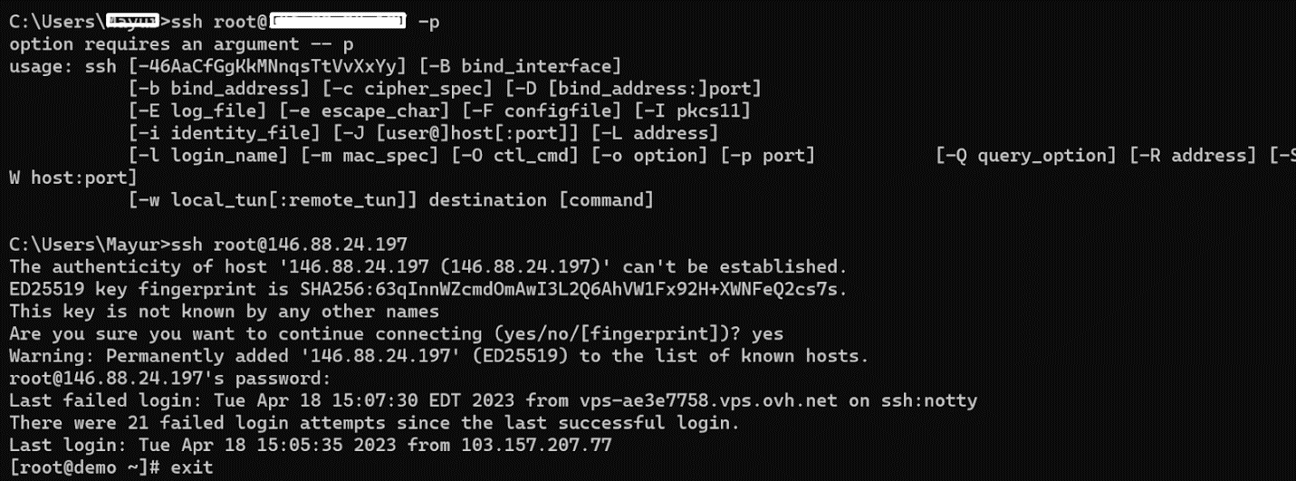

**scp**

Copies files securely between hosts using SSH.

*Syntax: scp [options] [source] [destination]*

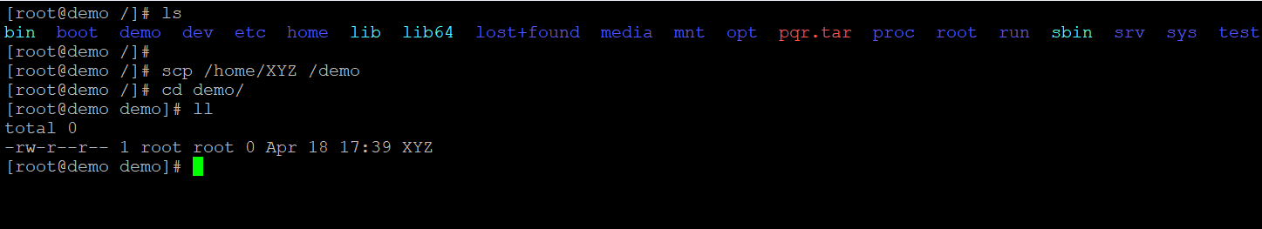

**ftp**

Transfers files between hosts using FTP.

*Syntax: ftp [options] [hostname]*

ftp command

**chmod**

Changes the permissions of files and directories.

*Syntax: chmod [options] [mode] [file/directory]*



**chown**

Changes the owner of files and directories.

*Syntax: chown [options] [owner:group] [file/directory]*

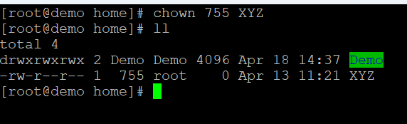

**passwd**

Changes the password of the current user.

*Syntax: passwd [options] [username]*

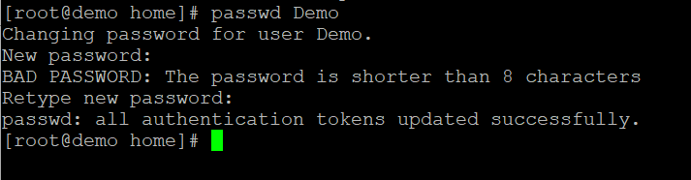

**su**

Switches to another user account.

*Syntax: su [options] [username]*

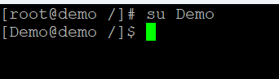

**sudo**

Executes a command with superuser privileges.

*Syntax: sudo [options] [command]*

**uname**

Shows system information.

Syntax: uname [options]

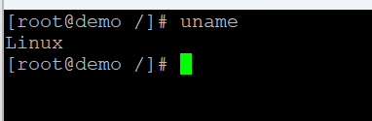

**date**

Shows the current date and time.

Syntax: date [options]

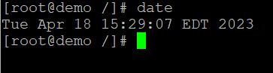

**cal**

Shows the calendar for the current month.

Syntax: cal [options]

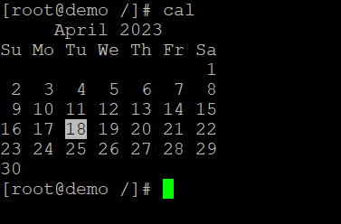

**uptime**

Shows the system uptime and load average.

Syntax: uptime [options]

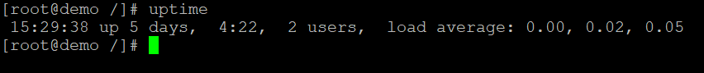

**free**

Shows the memory usage.

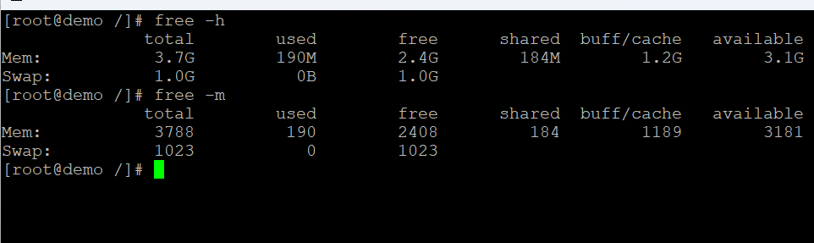

Syntax: free [options]

Also Read: [How Can I Check Memory Usage in Linux?](https://www.hostbillo.com/blog/how-can-i-check-memory-usage-in-linux/)

**top**

Shows the system resource usage.

Syntax: top [options]

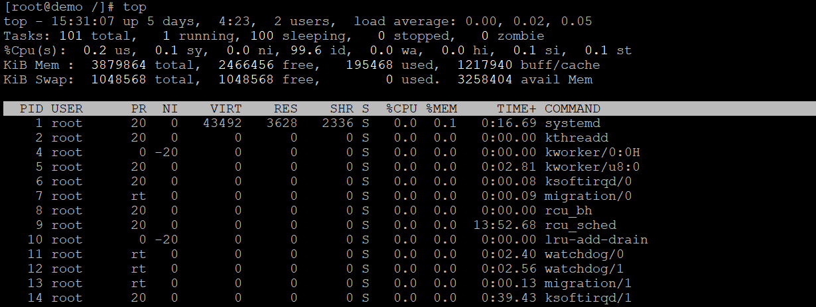

**history**

Shows the command history.

Syntax: history [options]

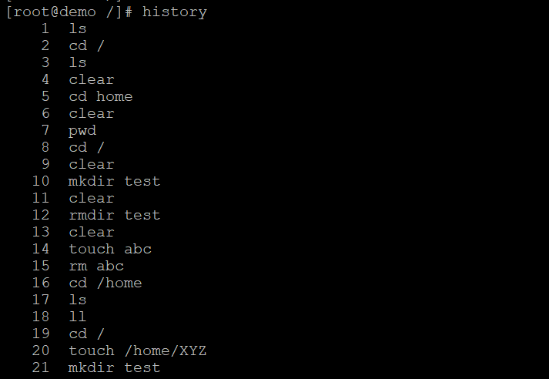

**tar**

Compresses or extracts files from an archive.

Syntax: tar [options] [archive-filename] [files/directories]

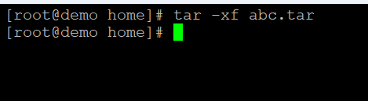

**ssh-keygen**

Generates SSH keys for authentication.

Syntax: ssh-keygen [options] [keyfile]

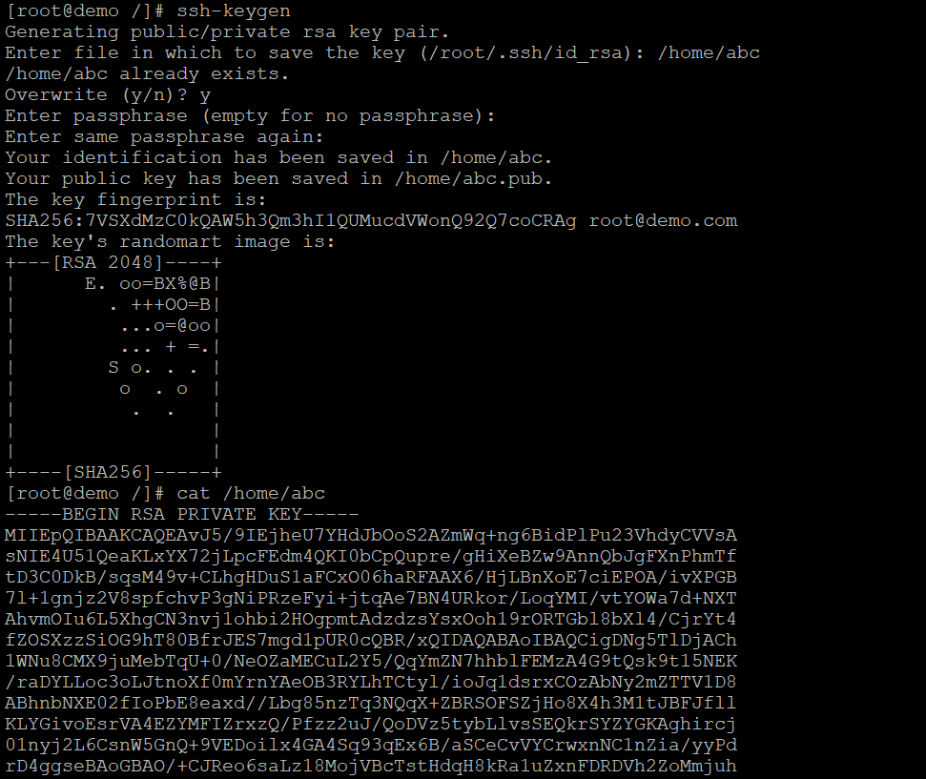

**crontab**

Schedules commands to run at specified times.

Syntax: crontab [options] [filename]

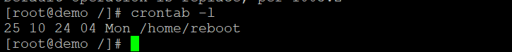

**systemctl**

Controls the system and service manager.

Syntax: systemctl [options] [command]

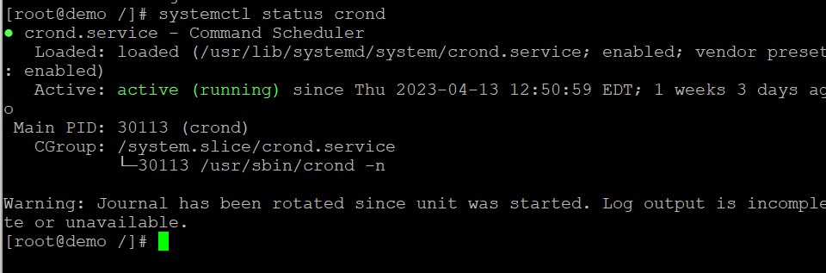

**ping6**

Tests the network connectivity to a host using IPv6.

Syntax: ping6 [options] [hostname/IP address]

**traceroute**

Shows the network path to a host.

Syntax: traceroute [options] [hostname/IP address]

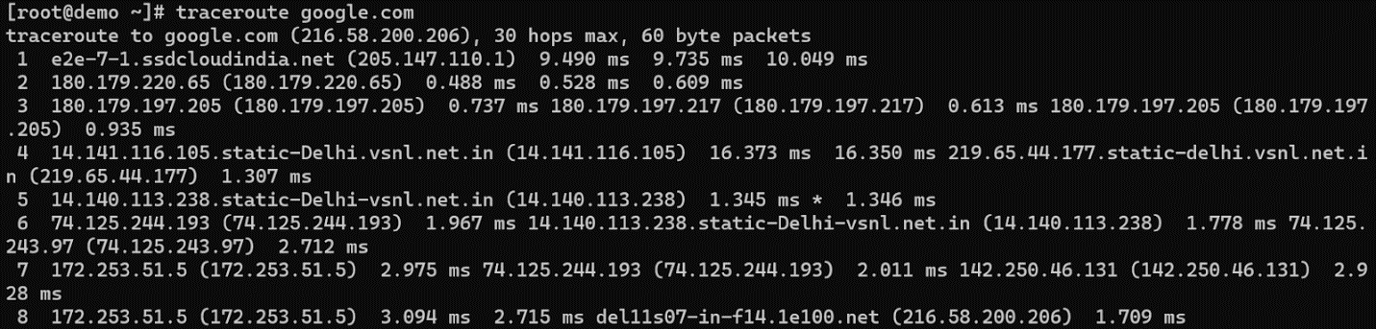

**sed**

A stream editor for modifying files.

Syntax: sed [options] [script] [filename]

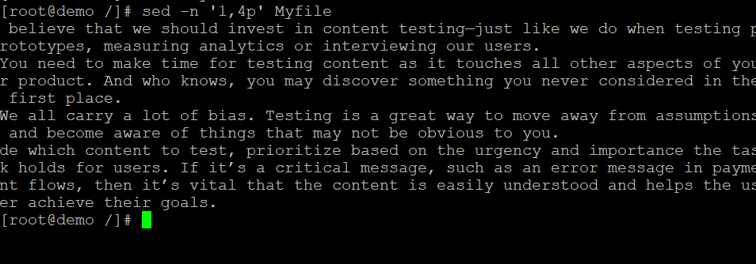

**awk**

A versatile tool for working with text files.

Syntax: awk [options] [script] [filename]

awk command

**cut**

Cuts out sections from a file.

Syntax: cut [options] [filename]

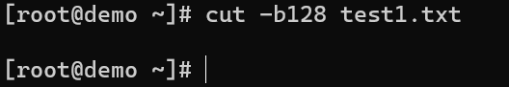

**paste**

Combines lines from multiple files.

Syntax: paste [options] [filename1] [filename2]

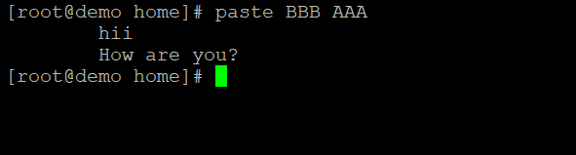

**sort**

Sorts lines of text.

Syntax: sort [options] [filename]

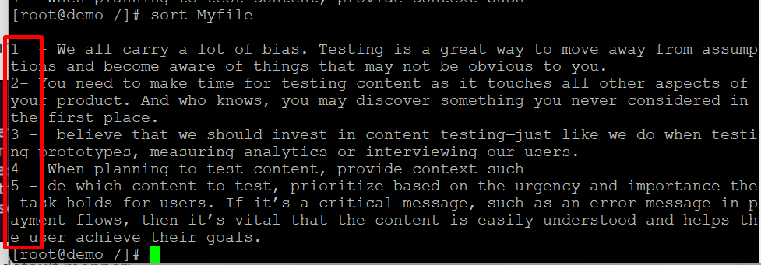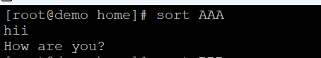

**uniq**

Removes duplicate lines from a file.

Syntax: uniq [options] [filename]

uniq command

**diff**

Compares two files and shows the differences.

Syntax: diff [options] [file1] [file2]

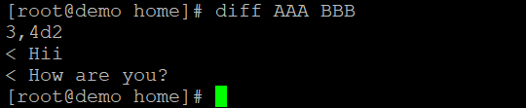

**patch**

Applies a patch file to a file.

Syntax: patch [options] [original-file] [patch-file]

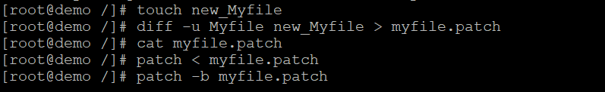

**tar**

Archives files and directories into a single file.

Syntax: tar [options] [archive-filename] [files/directories]



**zip**

Compresses files into a zip archive.

Syntax: zip [options] [zip-filename] [files/directories]

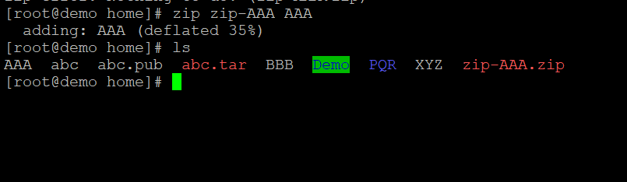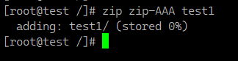

Also Read: [How to Zip a File in Linux?](https://www.hostbillo.com/blog/how-to-zip-a-file-in-linux-hostbillo/)

**unzip**

Extracts files from a zip archive.

Syntax: unzip [options] [zip-filename]

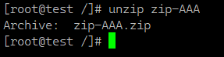

**curl**

Transfers data from or to a server.

Syntax: curl [options] [url]

curl command

**wget**

Downloads files from the web.

Syntax: wget [options] [url]

wget -N http://files.virtualizor.com/install.sh

wget command

**scp**

Copies files between hosts securely.

Syntax: scp [options] [source] [destination]

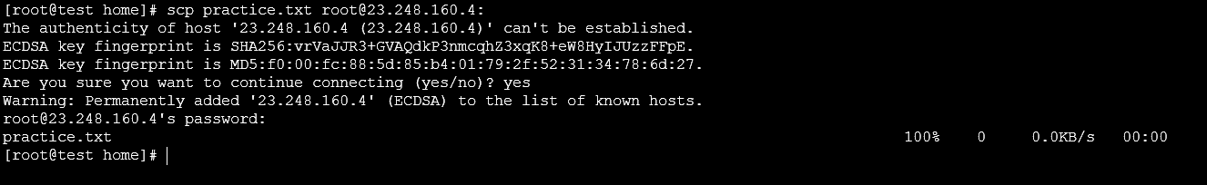

**rsync**

Syncs files and directories between hosts.

Syntax: rsync [options] [source] [destination]

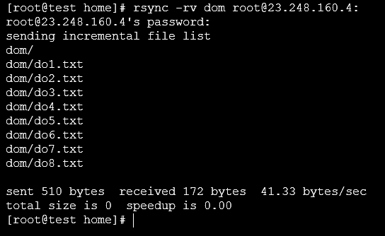

**mount**

Mounts a filesystem.

Syntax: mount [options] [device] [mountpoint]

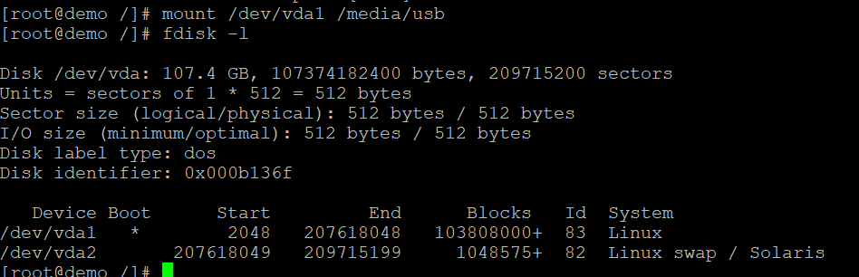

**umount**

Unmounts a filesystem.

Syntax: umount [options] [mountpoint]

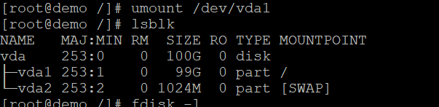

**killall**

Sends a signal to all processes with a given name.

Syntax: killall [options] [process name]

**ps aux**

Shows all running processes.

Syntax: ps aux

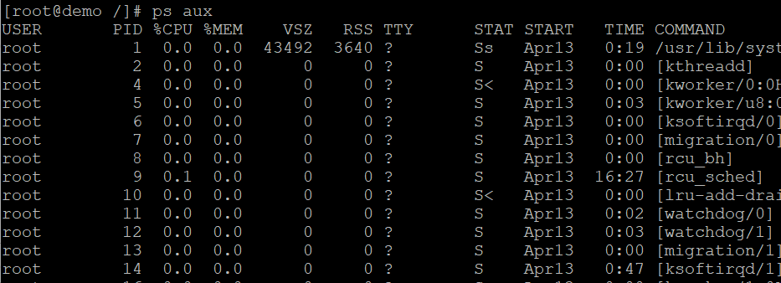

**who**

Shows all logged-in users.

Syntax: who

